Liverpool City Region Combined Authority Our Places consultation
Environment and Climate Change
All organisations and individuals need to understand what they can do to enable a greener city region. There needs to be real and substantial action, not just words of good intention. Please see Lord Debden, Chair of the Climate Change Committee letter dated 18th December 2019 at https://www.theccc.org.uk/publication/letter-ccc-writes-to-the-new-prime-minister/ . From our experience, there is too much unpopular and unsustainable planning of development in the countryside by the constituent authorities, despite the vast swathes of vacant and under-used brownfield sites. Regenerating brownfield sites reduces the need for long distance commutes, and utilises existing infrastructure, with a lower per capita carbon footprint. It really is common sense to develop such land in advance of our green fields. Brownfield first development must be at the heart of the SDS if it to achieve development in accordance with the revised National Planning Policy Framework (NPPF). We welcomed Steve Rotheram’s call to Government for a funding commitment to help tackle brownfield. https://www.liverpoolcityregion-ca.gov.uk/metro-mayor-calls-for-200m-to-clean-up-brownfield-sites-for-housing/. Boris Johnson has commented that he will support northern towns and cities to prosper and this is an issue that is a priority.
We acknowledge that the NPPF housing delivery test threatens countryside where enough land for development is not identified and that is why the Combined Authority must work with local authorities to identify all suitable brownfield land, and unlock land currently considered ‘unsuitable’. We will continue to urge Government to improve the NPPF in this regard. We want Combined Authorities to use effectively powers available to compulsory purchase land, for remediation and assembly and so more development can come forward on centrally located sites in our towns and cities. The release of Green Belt land should be a last resort, as it is a source for essential food, sustainable energy, re-wilding and carbon capture. Our industrial legacy will lead to blight and preventable green space loss. We have observed the economic and housing reports of GL Hearn, based on inflated economic growth forecasts, defy the realities of the economic uncertainties associated with Brexit, and other global shocks causing downturns. Consequently, the predicted very high growth is pushed outwards to the rural parts of the City Region, even into neighbouring areas such as West Lancashire. This is of course wrong as it is unsustainable growth, and it must be resisted as it is contrary to National Planning Policy Framework policies on Green Belt. Green Belt is a valuable asset, for food production, wildlife and amenity. The SDS should ensure the constituent local planning authorities focus on making the most of brownfield land reuse, and protect their Green Belt designations. The SDS must resolve the problem to be in line with sustainable development ambitions.
There ae many things that the waste authorities can do to help people dispose of waste more sustainably, but encouraging more sustainable consumption, such as eliminating the use of plastics and switching from palm oil (both of which directly impact on the climate) to other more sustainable oils are important issues too.
We recommend a yearly carbon budget performance review of actual achieved against targets at the City Region Scale. It should be publicly and easily available. It will facilitate the end goal and enable the people of Liverpool to feel more included in the process as they monitor what they themselves, the Council and its partners achieve. Over reliance on both plastics and palm oil has a direct impact on climate.
There can be no further delay in dramatically reducing carbon emissions. The SDS must commit to implementing ambitious measures to reach the welcome goal of net zero emissions by 2040 and that of the Government by 2050. The issues below are from CPRE’s manifesto at the General Election, but revised to fit the strategic devolved governance tier.
- Farming and land use – The countryside has huge potential to take carbon out of the atmosphere by restoring nature. We urge the Government to ensure payments to land managers should promote natural climate solutions that improve soil health and support the planting of many more trees and hedges. The Combined Authority should avoid focusing development in rural places and in green belt.
- Energy supply – Our energy system needs to be redesigned now to meet the zero carbon target. The Combined Authority should oppose exploration for new sources of fossil fuels, such as fracked gas, and invest instead in community-led renewable energy and promoting a reduce, reuse and recycle culture.
- Energy efficiency – Buildings must meet high standards of energy efficiency to prepare for a net zero future and tackle fuel poverty. The Combined Authority should develop and implement a strategy to reduce carbon emissions from our existing homes and invest in a programme of retrofit. Property developers should be encouraged in the planning process to build carbon neutral homes.
What evidence (for example studies, information, data) do you think is needed?
Climate Change Act 2008, as amended, June 2019.
The letter from Lord Deben, Chairman of the Committee on Climate Change, and Baroness Brown, Chair of the CCC’s Adaptation Committee, to new Prime Minister, Boris Johnson provides the Committee’s assessment of the priorities for the new Government to reduce UK emissions and prepare for climate change. https://www.theccc.org.uk/publication/letter-ccc-writes-to-the-new-prime-minister/. The CCC also has a number of useful publications https://www.theccc.org.uk/. The key think is for the Liverpool City Region to understand its role in this. What % of the national budget is Liverpool City Region responsible for?
The Greater Manchester Low Carbon Hub has made a lot of progress and the reports are relevant. http://gmgreencity.com/ Please Refer to The Conservative Manifesto 2019 (See pages 3 and 55) –ensure the Government keeps promises to the Public on this vital issue. We observed that 20,335 people in Liverpool City Region voted for the Green Party. The Labour Party held every seat, bucking the national trend and its manifesto was even more ambitious on the environmental issues than that of the Conservative Party. After considerable campaigning on this issue CPRE welcomes that there is cross-political party support for achieving our climate change goals, but we must see radical change in behaviours. The time for lip service has well and truly passed.
How important is this topic to you?
Very Important

Healthier, Safer and Resilient Homes and Communities
All of the above
The planning system when based on local democracy is a most powerful and effective tool. From building truly affordable homes to enhancing the countryside next door, the SDS must be based on good urban design and sustainable development principles.
CPRE Lancashire welcomed participation in the Liverpool Year of the Environment 2019 where the Mayor Steve Rotheram championed a green agenda. The SDS should progress the ambition for a green city region and empower the many communities across the Liverpool City Region to avoid discontent, by promoting development that responds to their needs, health and well-being in the most sustainable way. It must balance the needs of both developers and local communities to ensure viable schemes that are based on genuine sustainable town and country planning principles and good design and implementation of sound construction techniques. CPRE Lancashire believes it is unacceptable that some major developers, such as Persimmon and Bellway have been able to cut corners on home safety, whilst paying bosses excessive bonuses. The SDS should ensure minimum safety standards, so this does not happen in the City Region. Please see https://www.bbc.co.uk/news/business-48113301.
- The countryside next door and green space – Local countryside, parks and green spaces are an invaluable resource for addressing the climate emergency and improving health and wellbeing. The SDS should commit to enhancing and protecting them in and around our towns and cities, including the Green Belt.

- Brownfield – When countryside or green space is built on, it is lost forever, and with it the benefits it brings. The SDS should commit to a ‘brownfield first’ policy to ensure that suitable previously developed land is always the first site for new development. Well done to Steve Rotheram for championing this issue and calling for Government funding.

- Giving local council’s control – The Government via the NPPF has weakened the ability of local authorities to protect green space due to its harmful housing delivery test, which undermines the ability to put development in the right places. The SDS ought to find ways of effectively delivering enough brownfield land currently constrained through a mixture of compulsory purchase, land assembly and innovative partnering with developers. It should not sit back and allow speculative developers to simply suit themselves, and develop whenever profits are highest, irrespective of harm. Developers should be required to deliver housing types and tenures specified in the evidence bases of Local Development Plans and they should not escape this responsibility by pleading viability issues. Note judgment in case of [2018] EWHC 991 (Admin) – land value must be informed by policy. We hope Steve Rotheram and the Combined Authority’s planning team maintains brownfield regeneration as a priority for the SDS.
All of the above
The SDS must be based on community consultation and engagement and employ good urban design and sustainable development principles. The SDS planners therefore need to listen to the many communities across the Liverpool City Region and plan development accordingly to respond to needs, health and well-being in the most sustainable way.
Developments of low carbon footprint ought to be supported and embedded, and a rethink on public investment so any significant project that is contrary to climate change ambitions, such as unnecessary new road building should be scrapped. The approach must enable developers to bring forward viable schemes but based on urban concentration and at the correct density to make the most efficient use of land. The SDS must ensure it delivers only genuinely sustainable town and country planning principles and development of good design.
- The countryside and green spaces should be protected from development, including the Green Belt and made more accessible to the population of the City Region.
- All brownfield sites ‘suitable’ or otherwise should be recorded on the Brownfield Registers. The Combined Authority must consider how best to use available powers to compulsory purchase land for reuse in partnership with a range of partners, including Government that should help tackle economic imbalance and remove constraints that exist as a legacy of industrialisation. The SDS should commit to a ‘brownfield first’ policy and consider the use of target’s to keep track of progress. Given the wasted land resources across the Liverpool City Region there should be no exceptional circumstances to incur countryside encroachment and Green Belt loss by constituent authorities. This issue is very contentious locally. Green Belt is valuable for food production, wildlife and recreation.
- Supporting local councils to achieve housing delivery test targets through a mix of higher densities in appropriate locations and delivery of infrastructure to better support unsuitable brownfield to come forward more quickly than without targeted action.
What evidence (for example studies, information, data) do you think is needed?
Data on the link between good mental and physical health and access to green space and the natural environment. See Countryside Recreation Network: “A Countryside for Health and Wellbeing: the physical and mental helath benefits of green exercise” 2016; Houses of Parliament Parliamentary office of Science and Technology “Green Space and Health” 2014 ; “Returning public parks to their public health roots “ Centre for Public Health of Liverpool, John Moores University. Wheater et al 2007 and BMJ Open 2018 “Urban Green Spaces and Cancer”.
How important is this topic to you?
Very important
A Thriving and Vibrant City Region
All of the above
When planning for a thriving and vibrant City region our countryside should not be overlooked, as it is a source of wellbeing and wonder for everyone, wherever they live. The SDS must improve access to green spaces for everyone, particularly for children and those from disadvantaged communities who do not currently have access.
●Experiencing the countryside – A love of the countryside starts early and having it in our lives benefits our health and wellbeing. The SDS should enable every schoolchild to experience dark skies, whether locally or in a National Park or Area of Outstanding Natural Beauty, and include local opportunities to learn about the natural world.
● Caring for the countryside – Litter reaches even the most beautiful places in our countryside. The Combined Authority should set us on the path to a litter-free future, implementing an ‘all-in’ Deposit Return Scheme that collects cans and bottles of all shapes, sizes and materials.
●● Access – Too often, those from disadvantaged communities are unable to access the many benefits the countryside provides. The Combined Authority should give additional support for tried and-tested schemes to enable people from under-represented backgrounds to enjoy our Countryside, including investment in public transport links. In addition, a action plan to roll out the use of electric cars, via car clubs, and provision of widespread charging points throughout the Region is a must.
How should we tackle these challenges:
All of the above
We cannot create more greenfield land. Once it is built it is gone forever.
The Combined Authority needs to strategically plan for land uses to best locations to minimise our demand for travel. Urban concentration is a good policy as it leads to compact urban living, that supports vibrant economies and thriving businesses. Of course urban places must be verdant and provide quality environments in terms of health and well-being, with good urban realm and equally green infrastructure to filter pollution and provide residential amenity.
CPRE thinks if the SDS achieves liveable thriving towns and city, people will not seek to live in more rural places, with all the problems of additional commuter miles and lack of facilities.
Having people dispersed over wide areas is an inefficient use of land and contrary to the National Planning Policy Framework. Consumer spending is drawn spending across large areas and there is no vibrancy anywhere. Businesses struggle.
We need to support farmers and local food networks. People want to spend time in nature and see wildlife promoted. The visitor economy consists of people who go to nature reserves to see wildlife. This aspect must be considered by the SDS.
What evidence (for example studies, information, data) do you think is needed?
A thriving and vibrant city that is safe will encourage much greater use of urban space by everyone. The social and cultural benefits of being with diverse people of all ages are significant. See “Year of the Environment 2019 Liverpool City Region” publications, Nature Connected “Liverpool City Region: the Natural Capital Deal” ,The Urban Institute “Thriving Residents, Thriving Cities” and The Nature Conservancy “Outside our doors: the benefits of cities where people and nature thrive” How important is this topic to you?
Very important
A Connected City Region
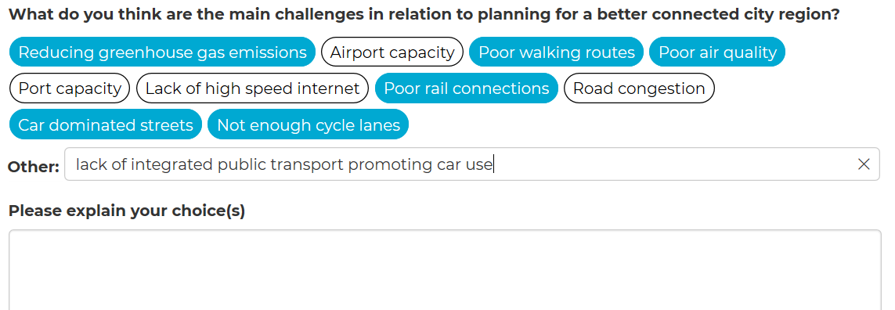
See highlighted above.
A lack of integrated public transport system promotes car dependency
CPRE Lancashire and CPRE Cheshire believes that the SDS needs to embed cleaner travel modes in the future. Airport expansion is contrary to commitments on climate change, even with improvements from the harnessing of new technology to reduce the carbon footprints of the passenger and freight movements. The airport is too car dependent. Generally, a significant reduction in car dependency is needed to reduce our greenhouse gases. Public transport – When there is only one bus a day to the nearest town, villages become isolated. The Combined Authority should shift planning investment from new road-building to funding for reliable, affordable, low-carbon public transport in rural areas to connect all communities to health and education services, leisure facilities, and employment opportunities. Active travel routes and infrastructure should be integrated with the public transport network. Neighbourhoods should be walkable and a reliance on the SMART growth principles.
The City Region is difficult to navigate via public transport and this should be better integrated in the future.
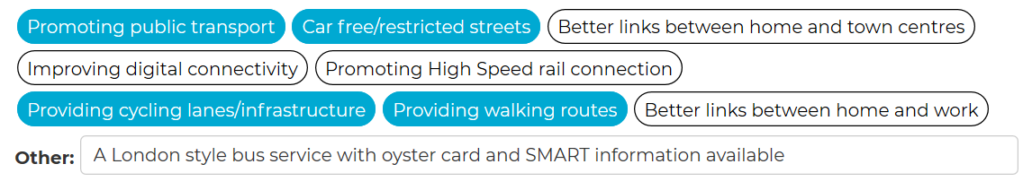
Please provide further information
The SDS should ensure that local land use and transport planning are effectively integrated, particularly where new development is planned. Major development should be focused where there is good public transport access and densities should be high enough to support local shops and other facilities within walking distance. This approach is sometimes known as ‘smart growth’ – see the further information section for a link to smart growth principles.
Local Transport Plans (LTP) which set out transport policies and proposals should seek to make the ‘fullest possible use’ of public transport and physically active travel. Bus use and cycling in particular make up a smaller proportion of journeys in the UK compared to other northern European countries.
The SDS must promote these more sustainable forms of travel and set a timetable to realistically grow the network over time – a ‘modal shift’ is essential if the City Region is to perform well against climate change targets.
http://www.smartgrowthuk.org/
https://bettertransport.org.uk/
An Inclusive Economy 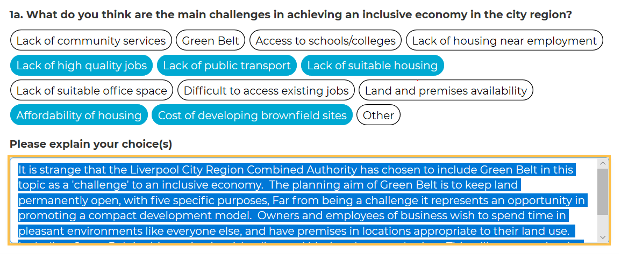
CPRE believes that the economy needs to be resilient by diversification in the different sectors, including in rural places. It should not become too narrowly focused.
Recently we have seen an increase in speculative B8 distribution and warehouse complexes in Green Belt along the motorways, without any duty to cooperate or due consideration of the cumulative impact, despite calls from constituency MPs to Government about the problems. Highways England has not properly consulted with the public and there remains substantial opposition. The expansion at Liverpool2 has no strategic rail link, which is a clear deficit when compared to the London equivalent. The sub- region must have more planning and public investment in rail freight. As far as we understand it there is no strategic plan for the very large increase in freight generated by Liverpool 2 which will impact regions far beyond Liverpool City Region whatsoever.
The SDS should prevent the controversial proposed access road through Rimrose Valley as it has a negative planning balance, due to harm to Green Belt, embedding unsustainable port transport, and other planning harms. This is an important Green Wedge. It provides a green corridor linking the most deprived areas with the countryside. We need more places like this, not less. It also encourages the continuation of road freight dependency rather than the use of the rail and canal network and is therefore inappropriate in the climate emergency. The rail network in the Liverpool City Region was in previous times much more comprehensive and there are opportunities to re-open stretches of rail to allow better connections, and where they cannot be re-opened enabled for public access and enjoyment, rather than being left as poor greenspace for the benefit of invasive species, like Japanese Knotweed. The Combined Authority must provide some real ambition and leadership.
There is a danger of unsuitable narrow, rural lanes in West Lancashire being used by HGVs and there are problems of congestion across the highway network, including the motorway network.
Regarding the Wirral Peninsula, it was agreed at the Public Inquiry in 1983, that the Wirral Green Belt was purposely drawn tightly as Wirral Borough was recognised being effectively an island, it had no land available for outward expansion. This was made possible by former Merseyside County Council exercising its strategic powers and we would hope the Liverpool City Region Combined Authority would do the same.
It is strange that the Liverpool City Region Combined Authority has chosen to include Green Belt in this topic as a 'challenge' to an inclusive economy. In doing so, the planning aim of Green Belt to keep land permanently open, and its five specific purposes are being misunderstood. Far from being a challenge to business, Green Belt represents an opportunity as it promotes urban regeneration and the viability of brownfield sites. Green Belt provides residential amenity, it is a place to get away from it all, and great for health and well-being of a workforce. Owners and employees of business wish to spend time in pleasant environments like everyone else, and have premises in locations appropriate to their land use. Including Green Belt in this section is misleading and biasing the consultation. This will taint the outcome of the consultation.
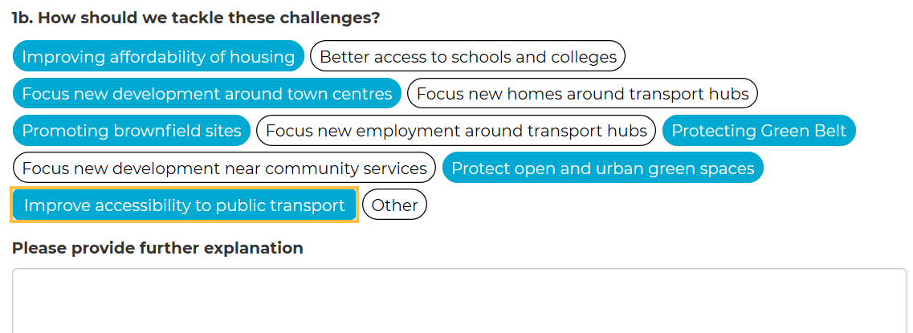
CPRE believes that the SDS should encourage a mix of businesses in growth sectors, but not be over-reliant on imports and associated B8 warehousing. No further large shed development should be permitted in Green Belt, due to the harms to its purpose. There must be much better duty to cooperate on this important issue.
The sub- region must have a plan for public investment in rail freight, otherwise the SuperPort is untenable.
The SDS should prevent the harm to Rimrose Valley Road.
The SDS should protect rural neighbours such as West Lancashire from being the target of urban sprawl, and support the development ambitions on brownfield sites in Liverpool, St Helens and Wirral. .
The Liverpool City Region Combined Authority should avoid targeting the Green Belt for development.

1c. What evidence (for example studies, information, data) do you think is needed?
The benefits of a fully integrated transport system are obvious – efficiency in time and fuel use, reasons to stop using cars rather than reasons not to stop, reduction in pollution and improvement in air quality and improvement in the travelling experience: a pleasure to use rather than a stressful experience. This is a wonderful opportunity for Liverpool City Region to lead the way in the UK or even Europe on being a truly green city region, shining a beacon for the environment and fighting climate change. It will increase visitor numbers and attract business.
http://www.smartgrowthuk.org/
1d. How important is this topic to you?
Important
The Infrastructure We Need
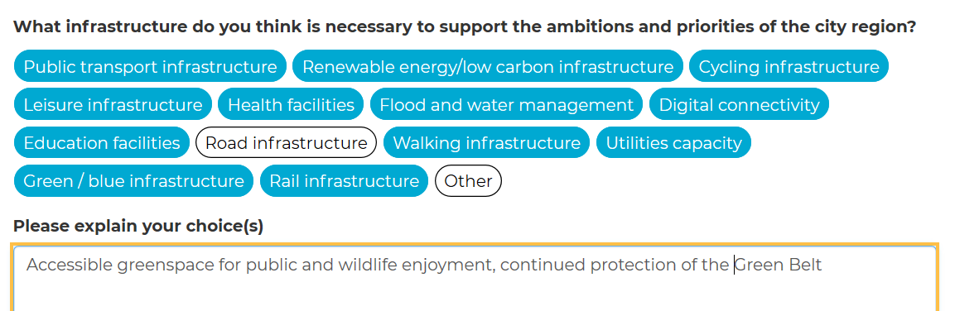
Road building induces more traffic, and along with it more journeys, more congestion and poorer air quality. It is directly opposed to tackling the climate change emergency. See the research report carried out by consultants Transport for Quality of Life (TfQL), which examined 86 official studies of completed road schemes. https://www.cpre.org.uk/resources/the-end-of-the-road-challenging-the-road-building-consensus/. More roads will equal more traffic and resultant carbon emissions.
We need less road investment and instead investment in public transport infrastructure.
We need more green infrastructure, that means more trees and hedgerows and keeping land such as Green Wedges and Green Belt permanently open.
Please provide examples of any specific infrastructure that you think is needed in the city region?
New footpaths, greenways, cycle lanes.
Integrated public transport.
More greenspace that promotes biodiversity.
How important is this topic to you?
Very important

