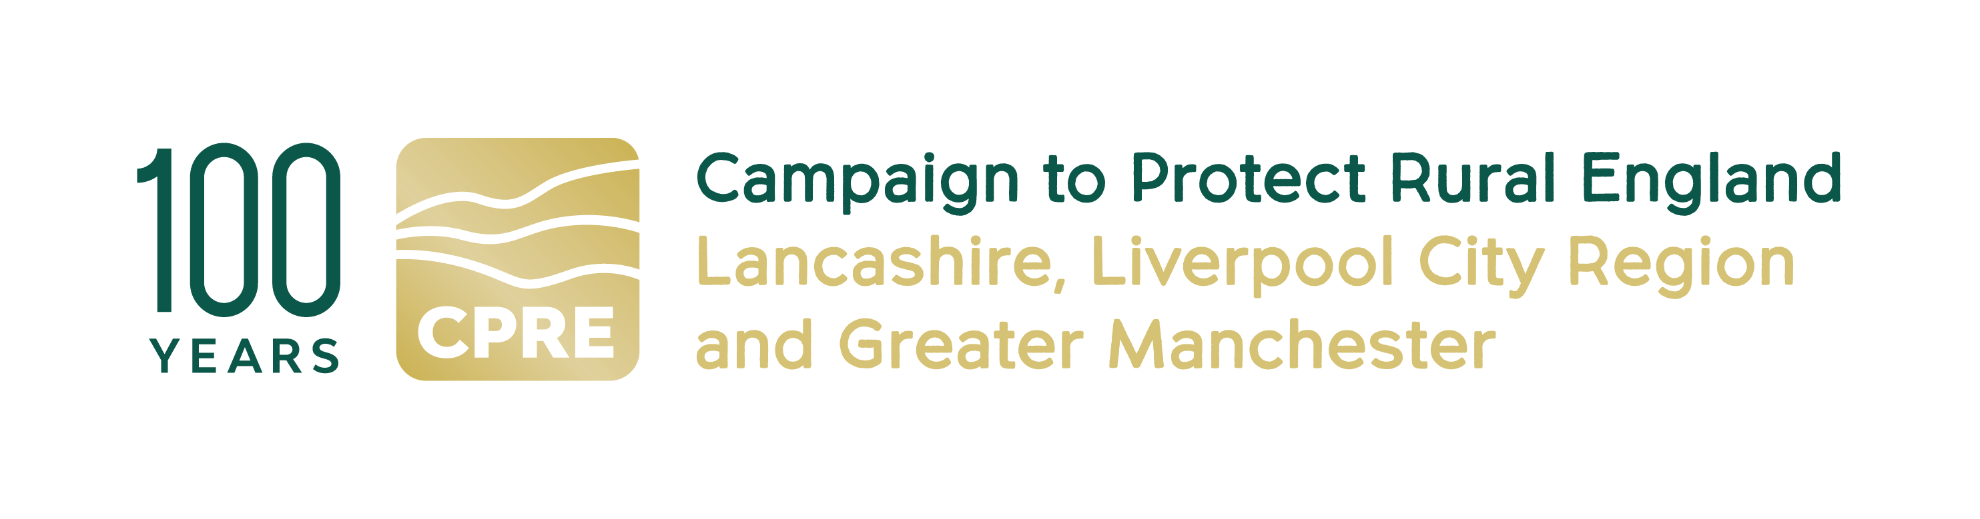

Community Engagement and Heritage Officer
for the Liverpool City Region Walking and Cycling Ringway

CPRE fights for a better future for the countryside. We work locally and nationally to protect, shape and enhance our beautiful countryside and green spaces for everyone to value and enjoy. This year we’re celebrating our 100th anniversary.

At CPRE Lancashire, Liverpool City Region & Greater Manchester, we have an exciting opportunity for a Community Engagement and Heritage Officer for the Liverpool City Region (LCR) Walking and Cycling Ringway.

The LCR Walking & Cycling Ringway is a new distinctive, accessible and environmentally sustainable 200-mile walking and cycling trail that joins all six LCR local authorities (Halton, Knowsley, Liverpool, Sefton, St Helens, Wirral). By bringing to life pathways and linking urban, coastal and rural landscapes, it will promote and protect the region’s key heritage and explore ways that local communities can engage with this heritage, shaped by an impactful community engagement programme. Its legacy will be one of positive economic impact on the region and on approaches to sustainable travel, as well as helping to increase the number of people who walk and cycle in the region, improving people’s activity levels and health outcomes.

The LCR Walking and Cycling Ringway will be a permanent resource for the Liverpool City Region.

Main purpose of the Community Engagement and Heritage Officer role:

In 2025, CPRE undertook a six-month R&D programme which included Community Engagement work across the LCR region and with partners. This culminated in a comprehensive Community Engagement report and a Feasibility Study.

We are now seeking an experienced and creative Community Engagement professional to implement the findings and recommendations of the Feasibility Study by designing, developing and leading an LCR Ringway community engagement programme with specific focus on the heritage aspects of the trail across all six LCR boroughs.

The Community Engagement and Heritage Officer will work with communities to co-create a programme that brings the trail’s landscape, heritage and stories to life, ensuring that access, inclusion and participation are at the heart of the programme.

The Community Engagement and Heritage programme will cover a 12-month delivery period.

Main responsibilities:

Community Engagement and co-creation
- Implement the findings and recommendations of the LCR Walking and Cycling Ringway R&D Community Engagement and Feasibility reports, with a focus on access, inclusion and participation.
- Develop, in collaboration with targeted communities from the six LCR boroughs, a timely and tailored community engagement programme that responds to the needs of these local communities and ways they can access and engage with heritage (heritage is natural, cultural, industrial and intangible).
- Conduct further detailed research into the communities we want to reach.
- Develop an approach and activities that meet accessibility and inclusion expectations.
- Build strong relationships with local residents, community groups, heritage groups, and cultural partners.
- Implement an activity programme that co-creates innovative approaches to the LCR Ringway eg new routes, shorter spurs, heritage-inspired walks etc
- Co-create an ancillary programme of guided walks
- Co-create heritage interpretation content for use on the trail.
- Explore storytelling / oral history initiatives
- Design and deliver a programme of events including heritage walks, family days, taster sessions, and pop-ups as required.
Partnership working
- Develop the work done at R&D stage with organisations, academic institutions, community groups, local authority officers, access bodies etc to help develop the Community Engagement programme.
Heritage
- Work with both private and public heritage organisations and bodies to identify ways communities can engage with them and ways the LCR Ringway can support their work.
- Work with LCR Destination partnership to identify heritage and community engagement opportunities.
- Work with local authority officers and other bodies to ensure that the LCR Ringway can support environmental plans and initiatives eg Local Nature Recovery Plan, Towns and Cities project and Climate Partnership work.

Access
- Oversee the work of the Disability Access consultant to ensure alignment with Community Engagement objectives.
- Work with LCR Destination on access initiatives.
- Work with disability advocacy and disability groups to co-create specific access initiatives eg shorter wheeled routes.

Volunteer Engagement & Skills Development

- Work with the freelance Volunteer Coordinator to ensure that objectives and outputs for the volunteer programme align with the Community Engagement programme.
Monitoring, Evaluation & Reporting
- Collect, record, and analyse participation data, demographic information, feedback, and qualitative insight. Capture photography, feedback, and evaluation data from all events.
- Provide regular updates for project progress reporting.
- Support the evaluation process in conjunction with the Project Manager, Project Officer and Evaluation Consultant. Ensure that Community Engagement work aligns with evaluation metrics.
Team
- Work with the Project Manager and Project Officer to ensure that all objectives, outcomes and outputs are delivered in line with the Project Plan and in a timely fashion over the course of the 12-month delivery period.

Required skills and competencies

Essential
- Track record of delivering high-quality community engagement projects that have access, inclusion and participation as key principles.
- Demonstrable experience of working with diverse communities and devising and implementing co-creation engagement programmes.
- Strong facilitation skills and confidence running workshops, events, and co-creation sessions.
- Experience developing interpretation content and storytelling rooted in local heritage.
- Excellent communication skills and ability to build positive relationships with stakeholders.
- Strong organisational skills and ability to manage multiple activities and deadlines.
- Experience gathering and reporting monitoring/evaluation data.

Desirable
- Experience working on rural, outdoor, landscape, or active-travel projects.
- Experience delivering grant-funded programmes.
- Knowledge of the Liverpool City Region, its communities and heritage
- Experience with oral history, recording techniques, and managing consent.

Key Employment Terms
- Fee £20,000
- Contract duration: 12 months
- Home-based, flexible working
- Manage days yourself, but should be regular working pattern over the 12 months. Based on our previous project to deliver the GM Ringway, we expect this role to require two - three days’ input a week.
- You need to be able to travel to meetings and events in the Liverpool City Region. Occasional evening and weekend work may be required. All reasonable travel expenses will be paid

Contact details:
If you are interested in this role, please email a CV (maximum 2 pages of A4) and covering letter (maximum 2 pages of A4) setting out how you meet the requirements of this post to:
info@cprelancashire.org.uk
For more information on this role, please call Nick Thompson 07736 123976 or email
Nickthompsoncpre@gmail.com or Lindsay Beaton on 07973 409415, email lrbeaton@hotmail.co.ukor visit our website http://www.cprelancashire.org.uk/

Closing Date: Midday Tuesday 30 June

Community & Heritage 7-6-2026

