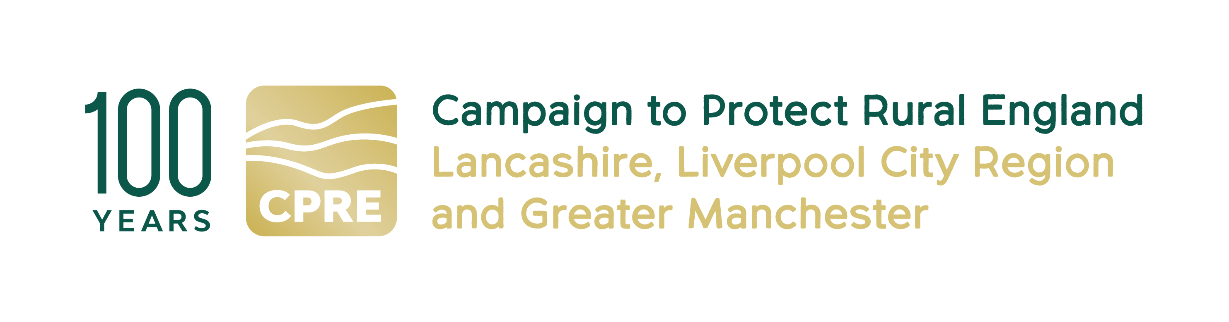

JOB BRIEF

PR Consultant
for the Liverpool City Region Walking and Cycling Ringway

CPRE fights for a better future for the countryside. We work locally and nationally to protect, shape and enhance our beautiful countryside and green spaces for everyone to value and enjoy. This year we’re celebrating our 100th anniversary.

At CPRE Lancashire, Liverpool City Region & Greater Manchester, we have an exciting opportunity for a PR Consultant for the Liverpool City Region (LCR) Walking and Cycling Ringway.

The LCR Walking & Cycling Ringway is a new distinctive, accessible and environmentally sustainable 200-mile walking and cycling trail that joins all six LCR local authorities (Halton, Knowsley, Liverpool, Sefton, St Helens, Wirral). By bringing to life pathways and linking urban, coastal and rural landscapes, it will promote and protect the region’s key heritage and explore ways that local communities can engage with this heritage, shaped by an impactful community engagement programme. Its legacy will be one of positive economic impact on the region and on approaches to sustainable travel, as well as helping to increase the number of people who walk and cycle in the region, improving people’s activity levels and health outcomes.

The LCR Walking and Cycling Ringway will be a permanent resource for the Liverpool City Region.

Main purpose of the PR Consultant

In 2025, CPRE undertook a six-month R&D programme to ascertain the viability of a new LCR Walking and Cycling Ringway. This culminated in a Feasibility Study which laid out specific recommendations that we will now implement at this delivery stage.

We are seeking an experienced PR Consultant to lead strategic communications for the LCR Walking and Cycling Ringway. The consultant will help raise the profile of the trail, increase visitor engagement, strengthen community relationships, and promote the trail as a key local asset for recreation, health, tourism, and sustainable transport.

Key responsibilities:

Strategic Communications
- Develop a PR and media strategy to promote the LCR Walking and Cycling Ringway regionally and nationally.
- Craft clear and compelling messaging tailored to targeted audiences

Media & Public Relations
  - Build and maintain relationships with local and regional media.
  - Prepare and distribute press releases, media packs, and feature stories.
  - Coordinate media visits, interviews, and photo opportunities.
Campaigns & Content
- Plan and deliver campaigns that promote LCR Ringway events, activities, and community programmes.
Stakeholder Engagement
- Support communication with local authorities, landowners, community groups, businesses, and tourism bodies.
- Help manage public feedback or sensitive communications where necessary.
Brand & Reputation Management
- Work with Project Manager and Project Officer to strengthen and protect the LCR Ringway’s public image through consistent messaging.
- Provide guidance on signage, visitor information, and tone-of-voice alignment.
- Work with the GM Ringway team to ensure alignment of both brands
Evaluation & Reporting
- Monitor media coverage and campaign performance.
- Provide monthly reports with insights and recommendations.

Required skills and competencies

- Proven and demonstrable experience and track record of successful PR campaigns preferably within heritage, tourism, environment, or culture.
- Strong media contacts and excellent writing and storytelling skills.
- Ability to communicate with a wide range of stakeholders sensitively and effectively.
- Experience delivering PR campaigns on limited budgets or for community-based projects.
- Strong organisational skills and the ability to work independently.
- Experience of delivering PR campaigns for grant-funded programmes.
- Knowledge of the Liverpool City Region, its communities and heritage

Key Engagement Terms
- Fee £11,000
- Contract duration: 12 months
- Home-based, flexible working
- Manage days yourself, but should be regular working pattern over the 12 months. Based on our previous project to deliver the GM Ringway, we expect this role to require up to two days’ input a week.
- You need to be able to travel to meetings and events in the Liverpool City Region. Occasional evening and weekend work may be required. All reasonable travel expenses will be paid

Contact details:
If you are interested in this role, please email a CV (maximum 2 pages of A4) and covering letter (maximum 2 pages of A4) setting out how you meet the requirements of this post to:
info@cprelancashire.org.uk
For more information on this role, please call Nick Thompson 07736 123976 or email
Nickthompsoncpre@gmail.com or Lindsay Beaton on 07973 409415, email lrbeaton@hotmail.co.uk or visit our website http://www.cprelancashire.org.uk/

Closing Date: 12noon Tuesday 30 June

