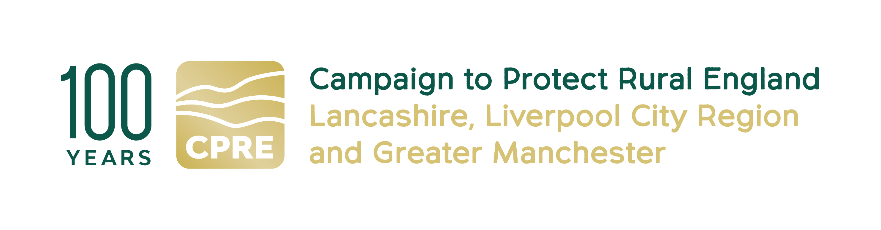

CPRE Project Manager
for the Liverpool City Region Walking and Cycling Ringway

CPRE fights for a better future for the countryside. We work locally and nationally to protect, shape and enhance our beautiful countryside and green spaces for everyone to value and enjoy. This year we celebrate our 100th anniversary.

At CPRE Lancashire, Liverpool City Region & Greater Manchester, we have an exciting opportunity to manage a new project to deliver the Liverpool City Region (LCR) Walking and Cycling Ringway.

The LCR Walking & Cycling Ringway is a new distinctive, accessible and environmentally sustainable 200-mile walking and cycling trail that joins all six LCR local authorities (Halton, Knowsley, Liverpool, Sefton, St Helens, Wirral). By bringing to life pathways and linking urban, coastal and rural landscapes, it will promote and protect the region’s key heritage and explore ways that local communities can engage with this heritage, shaped by an impactful community engagement programme. Its legacy will be one of positive economic impact on the region and on approaches to sustainable travel, as well as helping to increase the number of people who walk and cycle in the region, improving people’s activity levels and health outcomes.

The LCR Walking and Cycling Ringway will be a permanent resource for the Liverpool City Region.

This is a 12-month delivery project.

The delivery of the LCR Ringway will include the following activities:
- Detailed mapping of the walking and cycling route(s)
- Scoping of signage and interpretation
- An extensive community engagement and heritage programme to ensure access, inclusivity and participation
- Partnership work to build a robust network of partners and collaborators
- Ensuring the sustainability and legacy of the project
- Implementing a volunteer programme and skills development opportunities
- Ensuring that the project protects and enhances all elements of the region’s heritage: natural, cultural, (post) industrial and intangible
- Implementing digital assets and a content marketing and PR plan to promote the Ringway

Main purpose of the Project Manager role:

The postholder will take overall responsibility for delivery of the LCR Walking and Cycling Ringway project in 12 months from commencement, ready for launch in the summer of 2027 to coincide with the Tour de France Grand Départ from Liverpool.

Main responsibilities:

Project Management
- Lead day-to-day project management, ensuring delivery against the Project Plan, objectives, milestones and budget.
- Maintain the risk register
- Regular Project Board reporting and fulfilling funding reporting requirements
- Explore organisational structure options for legacy of the LCR Ringway
- Oversee successful and timely delivery of all workstreams including:
  - Route mapping
  - Wayfinding and signage installation
  - Community engagement & heritage activities
  - Volunteer recruitment, training, and management
  - PR, marketing, and digital communications
  - Digital marketing content plan
  - Environmental sustainability actions
Financial & Contract Management
- Monitor expenditure and cash flow, and maintain financial records
- Manage third party contractors and freelance consultants
- Manage procurement in line with organisational policies
- Forecast spend and adjust plans to remain on budget
Stakeholder Engagement
- Engage with landowners and local authorities, and ensure permissions where needed
- Implement a partnership and stakeholder strategy working with those who have been engaged with at R&D process and new partners
- Work with Peaks and Northern Footpath Society on implementing detailed partnership agreement
- Oversee work of Community Engagement Specialist
- Work with LCR Destination Partnership on visitor and economic opportunities
- Explore opportunities for working with local businesses for positive economic impact
- Support co-creation processes and ensure community voices shape the delivery programme.
Environmental Sustainability

- Ensure project delivers on environment objectives
- Work with CA Local Nature Plan and Climate Partnership teams to align Ringway with existing projects and explore new initiatives.
Monitoring, Evaluation & Reporting
- Implement the Evaluation Plan with the evaluation consultant
- Maintain evidence for all activities including engagement targets, heritage outcomes and digital outputs
- Deliver progress reports and final evaluation for funders
Communications & Digital Outputs
- Oversee design and development of LCR Ringway website
- Research app platform for digital delivery and work with provider to implement
- Work with PR/Marketing consultants to deliver impactful comms and content campaign
- Ensure the website and social content meet accessibility and any open-licensing requirements

Required skills and competencies:

- Experience in successfully delivering innovative and effective projects in either the private or public sector
- A knowledge of the social, economic and physical geography of Liverpool City Region
- Knowledge of project management tools to ensure effective and timely delivery of the project
- Experience of managing a core permanent team and a range of freelancer roles
- Strong financial management, budget tracking, procurement, and reporting skills
- Strong teamwork and communication skills and experience of working with local communities, councils, landowners, and stakeholders
- Demonstrable understanding of accessibility, inclusion, and audience development principles
- Strong organisational skills and ability to work independently and proactively.

Essential
- Experience of project planning and delivery to meet standards and deadlines
- Problem solving, especially in the context of overcoming obstacles to project delivery
- Innovation and creativity in delivering outcomes
- Identifying, engaging and collaborating with stakeholders to deliver projects
- Excellent written communication skills (including briefs and project reports)
- Excellent interpersonal skills; able to act as ‘the voice and face’ of the LCR Walking and Cycling Ringway.
- Ability to lead and motivate a team, including supporting them to deliver effective, focused and impactful outputs

Desirable
- Established contacts with stakeholders and potential partner organisations in the local government, activity/public health, and environmental sectors or the proven ability to establish these within a short time frame in Liverpool City Region.
- Knowledge of active travel, rural access, cycling and walking

Key Employment Terms
- Fee £25,000
- Contract duration: 12 months
- Home-based, flexible working
- Manage days yourself, but should be regular working pattern over the 12 months. Based on our previous project to deliver the GM Ringway, we expect this role to require two - three days’ input a week.
- You need to be able to travel to meetings and events in the Liverpool City Region. Occasional evening and weekend work may be required. All reasonable travel expenses will be paid

Contact details:
If you are interested in this role, please email a CV (maximum 2 pages of A4) and covering letter (maximum 2 pages of A4) setting out how you meet the requirements of this post to:
info@cprelancashire.org.uk
For more information on this role, please call Nick Thompson 07736 123976 or email
Nickthompsoncpre@gmail.com or Lindsay Beaton on 07973 409415, email lrbeaton@hotmail.co.uk or visit our website http://www.cprelancashire.org.uk/

Closing Date: 12noon Tuesday 30 June

Project Manager brief 7-6-2026

