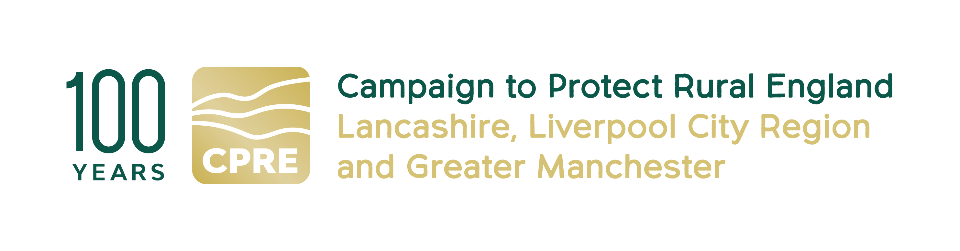

CPRE Project Officer
for the Liverpool City Region Walking and Cycling Ringway

CPRE fights for a better future for the countryside. We work locally and nationally to protect, shape and enhance our beautiful countryside and green spaces for everyone to value and enjoy. This year we celebrate our 100th anniversary.

At CPRE Lancashire, Liverpool City Region & Greater Manchester, we have an exciting opportunity to manage a new project to deliver the Liverpool City Region (LCR) Walking and Cycling Ringway.

The LCR Walking & Cycling Ringway is a new distinctive, accessible and environmentally sustainable 200-mile walking and cycling trail that joins all six LCR local authorities (Halton, Knowsley, Liverpool, Sefton, St Helens, Wirral). By bringing to life pathways and linking urban, coastal and rural landscapes, it will promote and protect the region’s key heritage and explore ways that local communities can engage with this heritage, shaped by an impactful community engagement programme. Its legacy will be one of positive economic impact on the region and on approaches to sustainable travel, as well as helping to increase the number of people who walk and cycle in the region, improving people’s activity levels and health outcomes.

The LCR Walking and Cycling Ringway will be a permanent resource for the Liverpool City Region.

This is a 12-month delivery project.

The delivery of the LCR Ringway will include the following activities:
- Detailed mapping of the walking and cycling route(s)
- Scoping of signage and interpretation
- An extensive community engagement and heritage programme to ensure access, inclusivity and participation
- Partnership work to build a robust network of partners and collaborators
- Ensuring the sustainability and legacy of the project
- Implementing a volunteer programme and skills development opportunities
- Ensuring that the project protects and enhances all elements of the region’s heritage: natural, cultural, (post) industrial and intangible
- Implementing digital assets and a content marketing and PR plan to promote the Ringway

Main purpose of the Project Officer role:

The postholder will help ensure smooth, timely and effective delivery of project activities across all workstreams, working closely with the Project Manager, freelance consultants, and partner organisations. They will also play a key role in collecting evidence for evaluation, supporting PR and digital activities, organising events, and ensuring the project is accessible, environmentally responsible, and community-centred.

Main responsibilities:

Project Delivery Support
- Assist the Project Manager in coordinating delivery across mapping, heritage, wayfinding, community engagement, volunteering, events, and digital activity.
- Help manage project timelines, logistics, activity schedules, and updates to the delivery plan.
- Support procurement processes (gathering quotes, organising documents, liaising with suppliers)
- Assist with communications to landowners, local authorities, community groups, and partners.
- Track and log permissions, conditions, and any site-specific considerations.
Digital

- Oversee agency work on design and development of website and assist PM with research and implementation of app platform
- Support with co-ordinating digital assets for content marketing
Administration & Coordination
- Manage calendars, bookings, registers, consent forms, and documentation.
- Keep project files organised.
- Co-ordinate financial administration (receipts, petty cash logs, event purchases).
Monitoring, Evaluation & Reporting
- Support with collecting and recording data for the project’s Evaluation Plan:
- Maintain accurate evidence files for reporting
- Assist with preparing reporting summaries and final evaluation report.
Environmental Sustainability

- Support environmentally responsible delivery of events and installations.
- Help monitor low-impact working methods (waste minimisation, habitat awareness, sustainable travel).
- Encourage participants and volunteers to adopt climate-aware behaviours.

Required skills and competencies

Essential:

- Experience supporting community, heritage, environmental, or outdoor projects.
- Strong organisational skills and ability to multitask across several workstreams.
- Confident communicator with excellent people skills and a friendly manner.
- Competent in gathering feedback, data entry, and maintaining records.
- Knowledge of website design and development
- Ability to work independently and proactively.
Desirable
- Experience co-ordinating grant-funded projects.
- Interest in or knowledge of the outdoors, active travel, rural access, cycling and/or walking, and heritage.
- Understanding of accessibility, inclusion, and safeguarding.

Key Employment Terms
- Fee £20,000
- Contract duration: 12 months
- Home-based, flexible working
- Manage days yourself, but should be regular working pattern over the 12 months. Based on our previous project to deliver the GM Ringway, we expect this role to require two - three days’ input a week.
- You need to be able to travel to meetings and events in the Liverpool City Region. Occasional evening and weekend work may be required. All reasonable travel expenses will be paid

Contact details:
If you are interested in this role, please email a CV (maximum 2 pages of A4) and covering letter (maximum 2 pages of A4) setting out how you meet the requirements of this post to:
info@cprelancashire.org.uk
For more information on this role, please call Nick Thompson 07736 123976 or email
Nickthompsoncpre@gmail.com or Lindsay Beaton on 07973 409415, email lrbeaton@hotmail.co.ukor visit our website http://www.cprelancashire.org.uk/

Closing Date: 12noon Tuesday 30 June

Project Officer 7-7-2026

