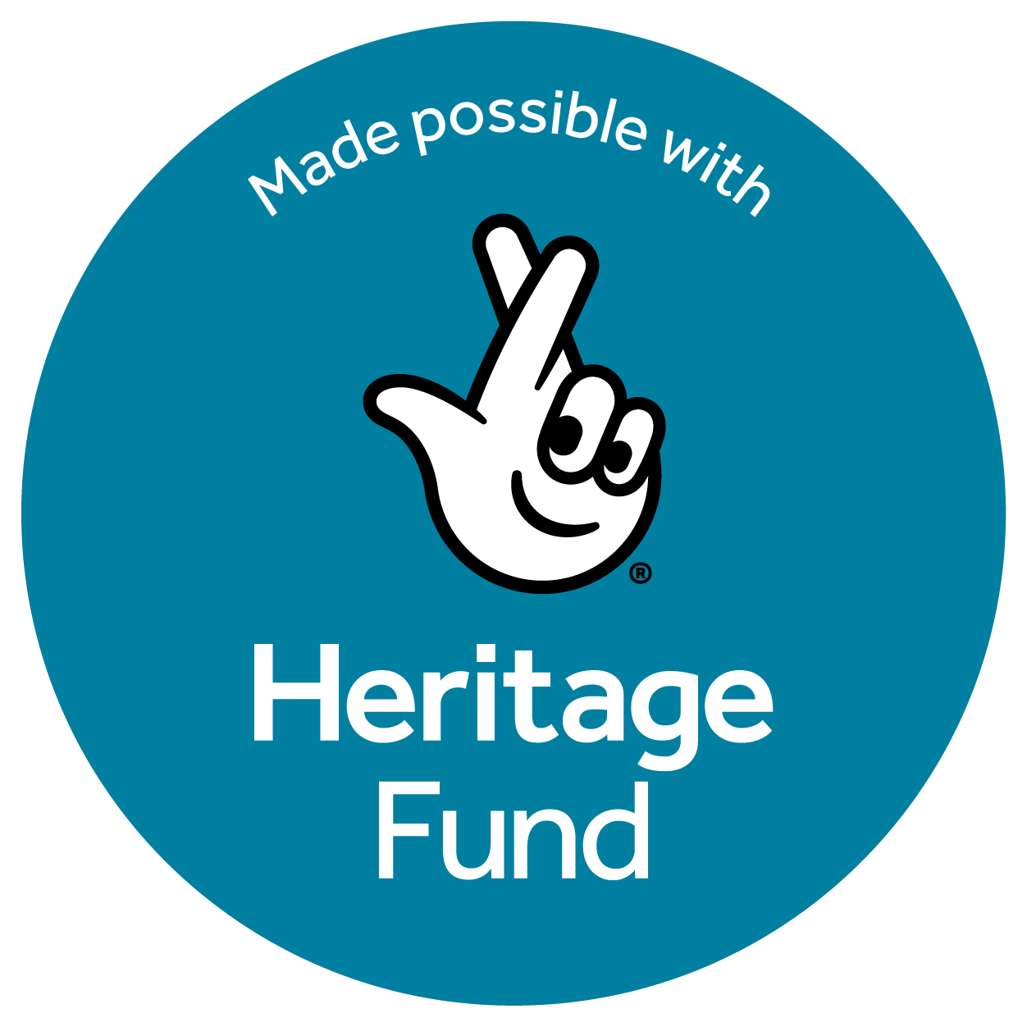



JOB BRIEF
September 2026

Freelance Events & Projects Officer
for the Liverpool City Region Walking and Cycling Ringway

CPRE fights for a better future for the countryside. We work locally and nationally to protect, shape and enhance our beautiful countryside and green spaces for everyone to value and enjoy. This year we celebrate our 100th anniversary.

At CPRE Lancashire, Liverpool City Region & Greater Manchester, we have an exciting opportunity for an Events & Projects officer to help deliver a new project: the Liverpool City Region (LCR) Walking and Cycling Ringway.

In 2025, a six-month R&D programme was undertaken to explore the feasibility of a walking and cycling route around Liverpool City Region. This resulted in a successful bid to the National Lottery Heritage fund for £245,000. A further £10,000 has been raised in sponsorship from the Peak and Northern Footpath Society (PNFS).

The LCR Walking & Cycling Ringway is a new distinctive, accessible and environmentally sustainable 200-mile walking and cycling trail that joins all six LCR local authorities (Halton, Knowsley, Liverpool, Sefton, St Helens, Wirral) and parts of West Cheshire. By bringing to life pathways and linking urban, coastal and rural landscapes, it will promote and protect the region’s key heritage and explore ways that local communities can engage with this heritage, shaped by an impactful community engagement programme. Its legacy will be one of positive economic impact on the region and on approaches to sustainable travel, as well as helping to increase the number of people who walk and cycle in the region, improving people’s activity levels and health outcomes.

The LCR Walking and Cycling Ringway will be made up of 20 stages across the region and in Cheshire West, with all stages accessible by public transport and the start and finish of the stage.

The delivery of LCR Ringway will commence in September 2026, with a Spring interim launch in March 2027 and a full launch in July 2027 to coincide with the Tour de France Grand Départ.

The delivery of LCR Ringway will commence in September 2026, with a Spring interim launch in March 2027 and a full launch in July 2027 to coincide with the Tour de France Stage 2 arrival in Liverpool.

The LCR Ringway project will be delivered by the wider team working with the Events and Project Officer and the scope of which includes the following activities:
- Detailed mapping of the walking and cycling route(s)
- Creation of a website and marketing/content assets
- An extensive community engagement and heritage programme to ensure access, inclusivity and participation
- A Spring programme of events
- Partnership work to build a robust network of partners and collaborators
- Ensuring the sustainability and legacy of the project
- Implementing a volunteer programme and skills development opportunities
- Ensuring that the project protects and enhances all elements of the region’s heritage: natural, cultural, (post) industrial and intangible
- Implementing digital assets and a content marketing and PR plan to promote the Ringway

Events and Projects Officer – main responsibilities:

Events
- Develop and deliver a ‘Spring programme’ of talks, guided and community walks and cycles, workshops and other ancillary events to help promote the LCR Ringway at its first launch period in March 2027. Working in consultation with the Project Leads, Community and Engagement Consultant, and PR Consultant.

- To develop and deliver other events when needed between March and July 2027 and around the Tour de France event in July.

- The Events Officer will be expected to develop full event plans, to source venues, produce timely risk assessments and any other related activity to deliver a successful programme of activity in the Spring.

Skills training research
Research, develop and deliver a programme of skills workshops (including storytelling, which is a key theme of the delivery programme) for volunteers and communities. These skills workshops may feature in the Spring programme and continue beyond to July and the full launch.

Content
Support the Marketing & Stories Consultant with the gathering, collating and editing of route information (eg Places to stay, places to eat and drink, heritage features) for the LCR Ringway website and app.

Active Travel
Liaise with transport providers across the region, and with Active Travel officers (Local Authorities; the Walk, Wheel, Cycle Trust etc) across the region:
- To ensure that all 20 stages of the route are accessible by public transport with a focus on rail, and to ascertain possible public transport breaks within the stages
- To provide accurate transport information for website and app
- To help rationalise and communicate ticketing options across the region
- To determine display opportunities at stations
- To confirm and develop promotional opportunities with Active Travel partners

Partnership activity
To develop existing and potential new partnerships with key regional organisations as identified in the R&D Feasibility Report. These will include the LCR Destination Partnership (visitor economy), Merseyside Sports Partnership, and Merseyrail (see also Active Travel above).

Heritage activity
To support the Community Engagement & Heritage Consultant with partnership work across key heritage assets along the route, exploring promotional and other opportunities.

Organisational sustainability
To research ways in which the LCR Walking and Cycling Ringway can become a sustainable organisation beyond the 12-month delivery period, producing an options appraisal and liaising with the Fundraising Consultant to identify sustainable funding sources.

Environmental Sustainability
To identify and develop environmental partnership opportunities with existing programmes as identified in the R&D Feasibility Report. These will include the Local Nature Recovery Plan, the NHLF-funded Nature, Towns and Cities programme and Nature Connected.

Monitoring, Evaluation & Reporting
Support the Project Leads with collecting and recording data for the project’s Evaluation Plan and assist with preparing reporting summaries and final evaluation report.

Required skills and competencies

Essential:

- Extensive and direct experience in developing and delivery of events programmes
- Experience in partnership / stakeholder development work
- Confident communicator with excellent people skills and a friendly manner
- Ability to work proactively and within a small team

Desirable
- Interest in or knowledge of the outdoors, active travel, rural access, cycling and/or walking, and heritage.
- Strong organisational skills and ability to multitask across several workstreams.
- Experience supporting community, heritage, environmental, or outdoor projects.
- Understanding of accessibility, inclusion, and safeguarding.

Key Employment Terms
- Fee £16,000
- Contract duration: 10 months
- Home-based, flexible working, but you will need to be able to travel to meetings and events in the Liverpool City Region. Occasional evening and weekend work may be required. All reasonable travel expenses will be paid.
- Manage days yourself, but should be regular working pattern over the 10 months.

Contact details:
If you are interested in this role, please email a CV (maximum 2 pages of A4) and covering letter (maximum 2 pages of A4) setting out how you meet the requirements of this post to:
info@cprelancashire.org.uk
For more information on this role, please email mandy@mandymartinez.co.uk
or visit the CPRE website http://www.cprelancashire.org.uk/

Closing Date: Friday 25th September

